**PRESS RELEASE**

**COMMUNICATIONS AND MEDIA TEAM OF THE 2023 ASEAN SUMMIT**

**No.32/SP/TKM-ASEAN2023/ENG/5/2023**

**National Police Forms Eight Task Forces to Anticipate Cyberattacks During ASEAN Summit**

**Jakarta, 5 May 2023 -** The Indonesian National Police (Polri) together with the National Cyber and Crypto Agency (BSSN) work together to anticipate cyberattacks during the 42nd ASEAN Summit 2023 in Labuan Bajo, East Nusa Tenggara (NTT), 9-12 May.

This was asserted by the Assistant Operations of National Police Chief, Inspector General Agung Setya Imam Effendy in a discussion at Forum Merdeka Barat 9 (FMB9) entitled "Readiness for the 42nd ASEAN Summit 2023 Labuan Bajo" in Jakarta, Friday, 5 May.

The National Police has also prepared special task forces to anticipate the possibility of cyberattacks.

"Regarding the potential disturbances that may occur in cyberspace, together with BSSN, we have organized an effort to secure the cyberspace," said Agung.

Cyberspace security arrangement is carried out under an integrated configuration with the BSSN, Polri, National Intelligence Agency (BIN) intel, and Indonesian Military (TNI) intel. "We will continue to collaborate and integrate with one another," he said.

According to Agung, the security aspect is not only what is visible, but also what is not visible, such as cyberattacks.

"Anticipation (of cyberattack) is continuously managed together with BSSN to ensure no cyber disturbances in all summit activities. We are doing the preparations and measures," said Agung.

Satrting on Friday, 5 May, Polri officially carried out a centralized security operation codenamed "Komodo 2023" which will be effective until 12 May. In total, eight task forces will take part in the operation, namely the Pre-emptive Task Force, the Preventive Task Force, the Walrolakir Task Force, the Gakum Task Force, the Action Task Force, the Anti-Terror Task Force, the Public Relations Task Force, and the Banops Task Force . These task forces are led by a one-star police general.

The Pre-emptive Task Force will be led by the Director of Special Security of National Police’s Intelligence Security Board (Dirkamsus Baintelkam); the Preventive Task Force will be led by the Director of Samapta Bhayangkara, Police’s Security Maintenance Board (Dirsabhara Baharkam Polri);the Walrolakir Task Force will be led by the Director of Law Enforcement of National Police Traffic Corps (Dirgakkum Korlantas)

The Action Task Force will be led by the head of Mobile Brigade Corps II; the Gakum Task Force by the director of Cyber Crime Bareskrim; the Anti-Terror Task Force will be led directly by the Anti-Terror Detachment 88 Action Directorate; the Public Relations Task Force by the head of the public information bureau of the National Police; and the Banops Task Force will be led by the head of the Technology, Information, and Communication Division of the National Police.(Laily Antara/TR/Elvira/ug/PPR)

***

For more information, please contact:

**Director General of Public Information and Communications of the Ministry of Communications and Informatics – Usman Kansong (0816785320).**

Get more information at <http://asean2023.id>, <https://infopublik.id/kategori/asean-2023>, and <https://indonesia.go.id/kategori/ragam-asean-2023>

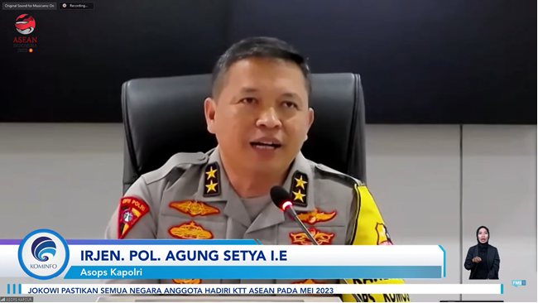

Assistant Operations of National Police Chief, Inspector General Agung Setya Imam Effendy in a discussion at Forum Merdeka Barat 9 (FMB9) entitled "Readiness for the 42nd ASEAN Summit 2023 Labuan Bajo" in Jakarta, Friday, 5 May 2023.